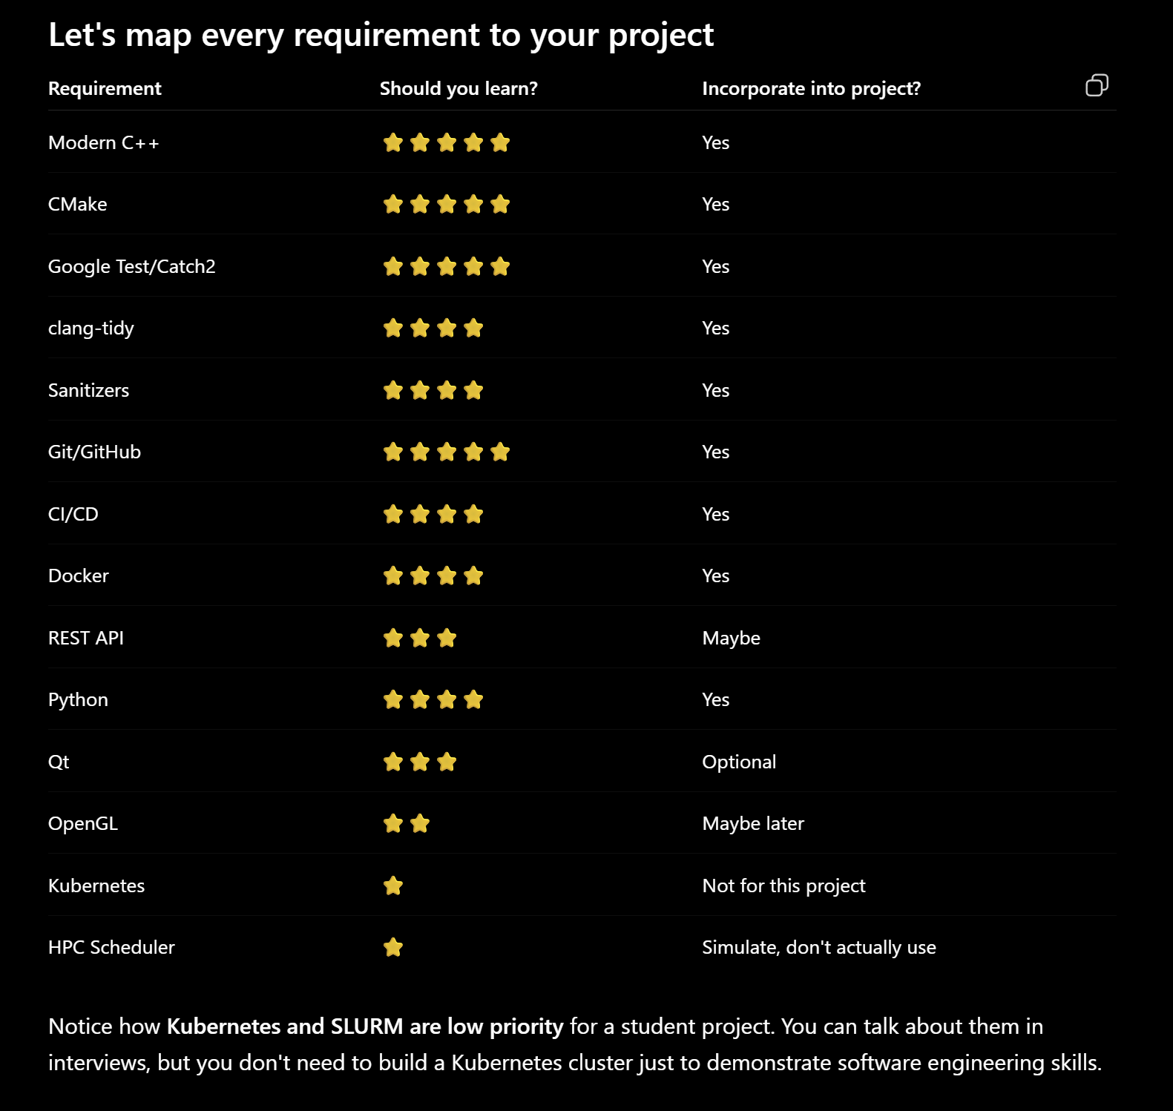
Layers | Tools | Explanation
Layer 1 - Core Library (C++) |  | Contains:  Battery model, Track model, Physics, Optimizer, Simulator  This is your "engine."
Layer 2 - Unit Tests | Google Test | Every class gets tested.  Now you're learning automated testing.
Layer 3 - Build System | CMake, Ninja, vcpkg | Instead of compiling manually.  Professional.
Layer 4 - Static Analysis | clang-tidy | It tells you things like:  - unnecessary copies  - unsafe code  - modern C++ suggestions  This is exactly what companies use.
Layer 5 - Sanitizers | AddressSanitizer  UndefinedBehaviorSanitizer | Compile with:  - AddressSanitizer  - UndefinedBehaviorSanitizer  They automatically detect  - memory leaks  - invalid pointers  - buffer overflows  This is invaluable in C++.
Layer 6 - CI/CD | Use GitHub Actions. | Every push automatically:  - Compile  - Run tests  - Run clang-tidy  - Run sanitizer build  That's literally CI.  Recruiters love seeing this.
Docker | Docker | Later in the project:  Create a Docker image.  Now anyone can run ers-optimizer without installing anything.  Again: Professional.
Python | Python | This one is actually extremely relevant. Don't write the simulator in Python. Write helper tools.  For example:  - Python  - Loads telemetry CSV  - Converts into JSON  - Feeds simulator  Or:  - Python  - Plots battery percentage  - Plots lap delta  - Plots deployment  That's exactly how many engineering teams work.  C++ for performance. Python for tooling.

This line: "Proven ability to own technical systems end-to-end."

They're saying can you take an idea then:
- Design it
- Build it
- Test it
- Deploy it
- Maintain it
- Document it

Your project can demonstrate every one of those.

Session 1
Install the tools.
Verify everything works.
Session 2
Create the Git repository.
Create the CMake project.
Build your first executable.
Session 3
Learn Git commits and branching.
Add your first Google Test.
Session 4
Design the architecture.
Session 5
Start implementing the Battery class.

